Exercises on High Voltage Engineering (April 3, 2025)

Lecture 7: Liquid and Solid Dielectrics

**4-2,，4-3，4-4，4-7，4-10，4-15**

**Supplementary Exercise 1:** The sample for measuring the volume resistivity *ρ*V and surface resistivity *ρ*S of the solid dielectric is as shown in the figure. The aluminum foil electrode is glued to the dielectric with Vaseline. The shape and size of the electrode are also shown in the figure. Assume that the measured volume resistance is *R*V and the surface resistance is *R*S. How to determine *ρ*V and *ρ*S?

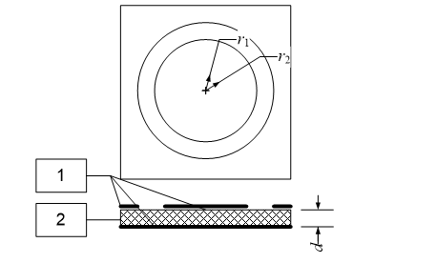

1 - Aluminum foil electrode; 2 - Dielectric

**Supplementary Exercise 2:** A cable is 100 m long, and the inner and outer radii of insulation layer are 5 cm and 15 cm respectively. The volume resistivity of the insulation at 20°C is *ρ*V = 3×1012 Ω·cm, and the temperature coefficient α = -0.02°C-1. Questions:

1.The insulation volume resistance of the cable at 20°C.

2.If the temperatures of the cable insulation layer are 10°C and 30°C, what are the resistances?

3.If the length of the cable is 200 m, what is the insulation volume resistance at 20°C?

**Supplementary Exercise 3:** A smooth porcelain rod with a radius of 5 cm has metal flanges at the top and bottom, with an insulation distance of 1 m. The volume resistivity is *ρ*V = 1×1013 Ω·cm, and the surface resistivity is *ρ*S = 3×1012 Ω. Questions:

1.Without and with a guard ring (auxiliary electrode), what are the measured insulation resistances?

2.If the surface resistivity *ρ*S decreases to 1×109 Ω due to moisture, what are the resistances in the above two cases?